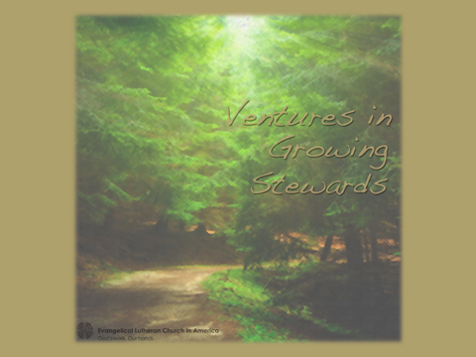

Ventures in Growing Stewards is a four-part workshop series that develops a vision and plan for growing stewards through a year round stewardship ministry. The process is organic in that each congregation develops an approach to fit their context and culture. With a trained leader provided by the synod, a cluster of six to eight congregations journey together for ten months. Each congregation has a team of four to six people. Eight different annual financial response alternatives are provided. The results have included spiritual renewal, developing a team-based approach to ministry, increases in regular giving, and growth in mission interpretation and support.

For more than ten years, the ELCA has offered a workshop entitled Ventures. Over this period more than 600 congregations and 3,000 leaders in more than thirty ELCA synods have learned how to grow faithful stewards and increase giving. For many congregations this experience included moving from a “paying the bills” approach to stewardship to a healthier response of “living the mission”.

The basic objectives of the Ventures in Growing Stewards are:
Build a foundation for growing good stewards of all ages to understand grace, gratitude and generosity through practical learning and skill development.

Ignite personal spiritual growth while creating enthusiasm for being an evangelizing congregation.
Equip congregational leaders in developing a vision and plan for living faith practices and strengthening year round ministry.
Accompany leaders in planning, implementing, monitoring and evaluating a year round ministry, including an invitation for an annual financial response and planned giving.
Foster stronger relationships within and among communities of faith as part of a common faith and mission.

These objectives are achieved through a series of four workshops in which the participants will:
Workshop I Six Hours Assess current stewardship understandings and culture. Introduce Five Essential Nutrients for a holistic approach
to a year round stewardship ministry
Learn basic guidelines to effective annual financial response
Workshop II Two Hours Conduct asset mapping activity apply to planning
Develop a vision for growing stewards and being missional
Receive training in a financial respose method
Workshop III Two Hours Explore competencies of a well-formed steward
Learn stages of steward leader development
Integrate dialogical education principles into activities
Workshop IV Two Hours Share results and learnings from annual financial response
Build a case for Mission Support
Learn how to develop Missional Spending Plan and
Missional Messaging

As part of this workshop series, participants will receive tools to grow in their personal stewardship and resources to teach others. Each participant will receive online access to assessment tools, education materials, communication elements and response methods. These will be helpful in completing the assignements between workshops and in impementing a year round plan.

If you are uncertain whether your congregation is ready to particpate in this workshop series, a positive response to three or more of the following questions will provide an indication:
- Are people in your congregation uncomfortable talking about money in church?
- Is your congregation stuck in scarcity thinking?
- Are you looking for new steward leaders to emerge?
- Has congregational giving been flat or declined?
- Are you leaders uncomfortable asking people to make a financial response?
- Has your congregation used the same response method for two or more years?
- Are you ready to move from an annual response to year round stewardship?
8. Is maintaining the momentum of year round stewardship a challenge?

For additional information about Ventures in Growing Stewards, contact the Director for Evangelical Mission in your synod or go to www.elca.org/Ventures.

