Completing an IRS W-2 sample form for Rev. Sue Doe.

Rev. Doe has a salary of $45,000 from the congregation. She is provided a parsonage and, pursuant to an estimate of such expenses and a properly adopted resolution, the church pays her an additional $1,500 parsonage utility allowance. This parsonage allowance is not included as income in Box 1 on Form W-2, but it may be reported in Box 14. If the church does not do so, it should report this amount to the pastor at year-end as an amount that she must include in Social Security income, along with the fair rental value of the parsonage.

Rev. Doe also receives a non-accountable annual travel allowance of $3,000. This entire sum is reportable income and must be added to the $45,000 salary to arrive at annual income of $48,000.

There is also an accountable reimbursement policy in place for other professional business expenses with a total amount of $2,500. None of this amount is to be reported on a Form W-2. (Note: Travel/vehicle expenses can be handled by an accountable reimbursement policy as well; this would be in lieu of a travel allowance.)

The congregation makes a Board of Pensions (BOP) contribution of $4,500. This is not reported as income, but the pension plan section is checked in Box 15. The pastor contributes $1,000 pre-tax dollars out of her salary to her 403(b) plan, which the church sends directly to the BOP at her request.

Rev. Doe has not requested any federal income tax withholding by the church (by using IRS Form W-4) and rather has assumed the obligation of making quarterly payments. The church pays (out of the church’s own budget and not as a salary reduction) a health insurance premium to the BOP in the amount of $3,000, which is not taxable income.

Box 1 of Form W-2 reports wages and tips of $47,000, consisting of the salary ($45,000) and the travel allowance ($3,000) less the before-tax 403(b) contribution of $1,000. None of the accountable reimbursement amount ($2,500) is included in Box 1, and these expenses are not reported on the pastor’s tax return. (If the pastor wishes to take deductions for travel expenses that are not reimbursed, those deductions must be reported on Schedule A as opposed to Schedule C.)

Reportable Income Items
Annual salary $45,000.00
Travel allowance 3,000.00

Reductions of Income (Before tax)
403(b) Contribution 1,000.00
Non-reportable Funds
Accountable reimbursement policy for business expenses 2,500.00
Parsonage allowance (for utilities for the parsonage) 1,500.00
Medical insurance premium 3,000.00 BOP pension contribution 4,500.00
Rental value of parsonage provided to pastor not reported

Box 2 is not completed, as Rev. Doe did not choose to have any voluntary income tax withholding, but rather paid estimated taxes directly. If the church withheld pursuant to Form W-4, such amounts would be reported here.

Boxes 3-6 should not have any entries (do not use “0”s). While clergy are considered employees for income tax purposes, they must individually report Social Security and Medicare.

Box 12 shows the codes relating to the voluntary salary reduction contributions - E $1,000.

Box 13 will show an X in the box for Retirement Plan.

Box 14 may include the housing allowance of $1,500. If not supplied here, the figure should be given to the pastor along with Form W-2 - both as a reminder of the amount and the fact that it is subject to Social Security contributions (SECA).

Boxes 16-21 should be completed according to your own state requirements, but in most cases it would be the same as Box 1.

For those seeking more information, they should refer to IRS Publication 517 https://www.irs.gov/pub/irs-pdf/p517.pdf and the current IRS instructions. These additional resources should answer any questions that go beyond the scenario set forth above. For further information, you should consult with a local tax preparer or expert.

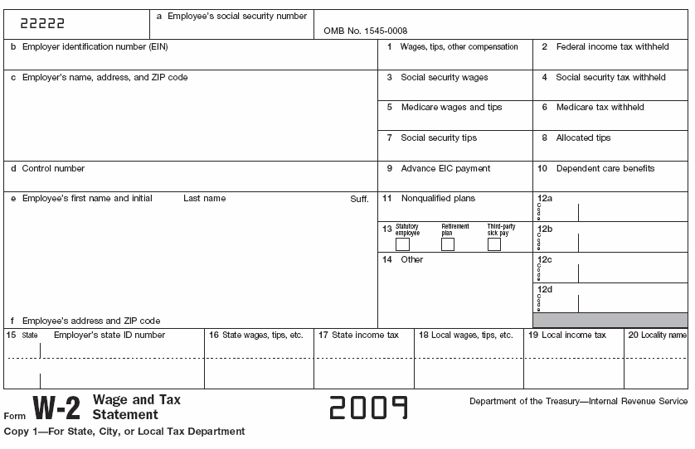
Rev. Sue Doe
123 Main St
Anytown, IL 60001
41-0000000
Joy Lutheran Church
987 Main St
Anytown, IL 60001
47,000
x
1,000
Housing 1,500
SAMPLE
000-00-0000
E

